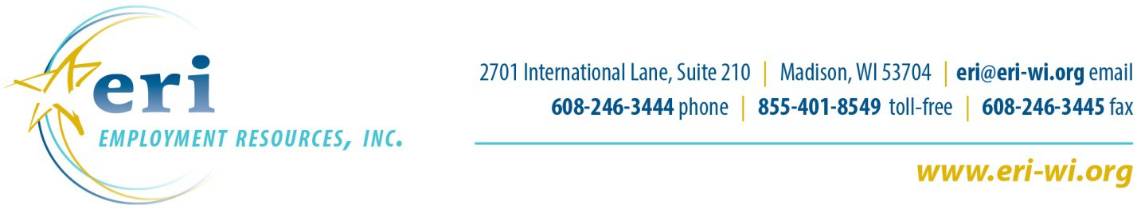

Interest Form
ERI Board Membership or Workgroup

Thank you for your interest in the ERI Board of Directors or related workgroups. ERI’s mission is to advance employment, health and financial security for people with disabilities. The Board values the diversity and commitment that Board and Workgroup Members bring to the organization.

Please use this form to tell us a bit about yourself and your interest in serving ERI. We appreciate your taking the time in providing this information. Let us know if you’d like more information about ERI as well.

Please return the completed form to wroblewski@eri-wi.org, mail to Beth’s attention at the address noted above, or complete online at www.eri-wi.org.

Someone will follow-up with you once the form has been submitted. This form is used as an ongoing recruitment tool, and ERI may or may not currently have Board and/or Workgroup openings.

Date:
- Interested in Board Membership
- Interested in Serving on a Workgroup
- Interested in Either Role

Name:
First Last

Contact Information:

Street Address:

City:

Phone:
State:

Zip Code:

Email:
Please tell us about your interest in serving on the ERI Board.

What contributions do you believe you would make as an ERI Board Member?

Please share some of your background and experience including any specific knowledge, interests and expertise that you have that could relate to ERI’s mission.

Please list any boards and committees that you serve or have served on (business, civic, community, fraternal, political, professional, recreational, religious, social).

Organization Role Dates of Service

1.

2.

3.

Skills, experience and interests (Please check all that apply)
☐Disability Related Experiences
☐Employment and Employer Relationships
☐Education
☐Finance/Accounting
☐Fundraising
☐Legal or Legislative
☐Management/Organization/Administration
☐Marketing/Public Relations
☐Outreach
☐Other:

Thank you very much for your interest.

